**TITLE TITLE TITLE**

**Name SURNAME[1]**

**Abstract**

There will be a Turkish and English abstract text of 100-300 words briefly stating the article's purpose, scope, research method and study results. Keywords related to the article will be located just below the abstract text. Keywords should be a minimum of two and a maximun six words. Then a three-character “JEL Classification” will be included in the article's subject. Studies must include a minimum three JEL classifications. There will be a Turkish and English abstract text of 100-300 words briefly stating the article's purpose, scope, research method and study results. Keywords related to the article will be located just below the abstract text. Keywords should be a minimum of two and a maximun six words. Then a three-character “JEL Classification” will be included in the article's subject. Studies must include a minimum three JEL classifications. There will be a Turkish and English abstract text of 100-300 words briefly stating the article's purpose, scope, research method and study results. Keywords related to the article will be located just below the abstract text. Keywords should be a minimum of two and a maximun six words. Then a three-character “JEL Classification” will be included in the article's subject. Studies must include a minimum three JEL classifications.

**Keywords:** Keyword 1, Keyword 2, Keyword 3

**JEL Classification**: JEL 1, JEL 2, JEL 3

**BAŞLIK BAŞLIK BAŞLIK**

**Öz**

Makalenin amacını, kapsamını, kullanılan araştırma yöntemini ve çalışma sonuçlarını kısaca belirten 100-300 kelime arası Türkçe ve İngilizce özet metni yer alacaktır. Özet metninin hemen altında makaleye ilişkin anahtar kelimeler yer alacaktır. Anahtar kelimeler en az iki en çok altı kelime olmalıdır. Ardından makalenin konusunun dahil olduğu üç karakterli “JEL Sınıflaması” yer alacaktır. Çalışmalarda en az üç JEL sınıflaması bulunmalıdır. Makalenin amacını, kapsamını, kullanılan araştırma yöntemini ve çalışma sonuçlarını kısaca belirten 100-300 kelime arası Türkçe ve İngilizce özet metni yer alacaktır. Özet metninin hemen altında makaleye ilişkin anahtar kelimeler yer alacaktır. Anahtar kelimeler en az iki en çok altı kelime olmalıdır. Ardından makalenin konusunun dahil olduğu üç karakterli “JEL Sınıflaması” yer alacaktır. Çalışmalarda en az üç JEL sınıflaması bulunmalıdır. Makalenin amacını, kapsamını, kullanılan araştırma yöntemini ve çalışma sonuçlarını kısaca belirten 100-300 kelime arası Türkçe ve İngilizce özet metni yer alacaktır. Özet metninin hemen altında makaleye ilişkin anahtar kelimeler yer alacaktır. Anahtar kelimeler en az iki en çok altı kelime olmalıdır. Ardından makalenin konusunun dahil olduğu üç karakterli “JEL Sınıflaması” yer alacaktır. Çalışmalarda en az üç JEL sınıflaması bulunmalıdır.

**Anahtar kelimeler:** Anahtar kelime 1, Anahtar kelime 2, Anahtar kelime 3

**JEL Sınıflaması:** JEL 1, JEL 2, JEL 3

**1. Introduction**

The text should be written in Times New Roman, 12-font size, justified, and 1.5 line spacing. There should be a 0 pt space before paragraphs and an 8 pt space after paragraphs. Considering the content of the study, the text should be divided into sections and sub-headings according to the subject headings and arranged according to the decimal system (1.1, 1.1.1, 1.2, 1.2.1 etc.). Section headings should contain only the first letter in CAPITAL characters, Times New Roman, 12-font size, Bold, left aligned, and numbered. A line spacing should be left after the heading. A line spacing should be left after the title and headings should not remain at the end of the page.

**2. Heading**

The text should be written in Times New Roman, 12-font size, justified, and 1.5 line spacing. There should be a 0 pt space before paragraphs and an 8 pt space after paragraphs. Considering the content of the study, the text should be divided into sections and sub-headings according to the subject headings and arranged according to the decimal system (1.1, 1.1.1, 1.2, 1.2.1 etc.). Section headings should contain only the first letter in CAPITAL characters, Times New Roman, 12-font size, Bold, left aligned, and numbered. A line spacing should be left after the heading. A line spacing should be left after the title and headings should not remain at the end of the page.

**2.1. Sub-Heading**

The text should be written in Times New Roman, 12-font size, justified, and 1.5 line spacing. There should be a 0 pt space before paragraphs and an 8 pt space after paragraphs. Considering the content of the study, the text should be divided into sections and sub-headings according to the subject headings and arranged according to the decimal system (1.1, 1.1.1, 1.2, 1.2.1 etc.). Section headings should contain only the first letter in CAPITAL characters, Times New Roman, 12-font size, Bold, left aligned, and numbered. A line spacing should be left after the heading. A line spacing should be left after the title and headings should not remain at the end of the page.

The text should be written in Times New Roman, 12-font size, justified, and 1.5 line spacing. There should be a 0 pt space before paragraphs and an 8 pt space after paragraphs. Considering the content of the study, the text should be divided into sections and sub-headings according to the subject headings and arranged according to the decimal system (1.1, 1.1.1, 1.2, 1.2.1 etc.). Section headings should contain only the first letter in CAPITAL characters, Times New Roman, 12-font size, Bold, left aligned, and numbered. A line spacing should be left after the heading. A line spacing should be left after the title and headings should not remain at the end of the page.

Tables, graphs, and figures are numbered separately in each section and appendix. Table, graph, and figure names are written right next to the number. Tables, graphs, and figures should be placed with a line space below the number and name line. The title should be in Times New Roman, 12-font size, centered, and bold. A reference text is given after the lower border of tables, graphs, and figures, without any spaces. The source reference is “Source: ……” under the table, graph, or figure, and is written in Times New Roman, 10-font size, left-aligned, with only the text "Source" in bold.

In model representations, the figures should be grouped as a single element so that their integrity is not changed.

**Table 1. Title sample**

|  |  |  |  |  |
| --- | --- | --- | --- | --- |
| **Variables** | **B** | **β** | **T** | **p** |
| Constant | 2.17 |  | 3.09 | 0.000 |
| Variable 1 | 0.21 | 0.32 | 1.86 | 0.000 |
| Variable 2 | 0.32 | 0.44 | 2.36 | 0.000 |
| Variable 3 | 0.12 | 0.11 | 1.18 | 0.000 |

**Source:** Times New Roman, 10 point, left aligned, only the text "Source" in Bold.

Tables, graphs, and figures are numbered separately in each section and appendix. Table, graph, and figure names are written right next to the number. Tables, graphs, and figures should be placed with a line space below the number and name line. The title should be in Times New Roman, 12-font size, centered, and bold. A reference text is given after the lower border of tables, graphs, and figures, without any spaces. The source reference is “Source: ……” under the table, graph, or figure, and is written in Times New Roman, 10-font size, left-aligned, with only the text "Source" in bold.

In model representations, the figures should be grouped as a single element so that their integrity is not changed. In model representations, the figures should be grouped as a single element so that their integrity is not changed. In model representations, the figures should be grouped as a single element so that their integrity is not changed. In model representations, the figures should be grouped as a single element so that their integrity is not changed. In model representations, the figures should be grouped as a single element so that their integrity is not changed.

**Graph 1. Title sample**

**Source:** TURKSTAT Labor Statistics

Tables, graphs, and figures are numbered separately in each section and appendix. Table, graph, and figure names are written right next to the number. Tables, graphs, and figures should be placed with a line space below the number and name line. The title should be in Times New Roman, 12-font size, centered, and bold. A reference text is given after the lower border of tables, graphs, and figures, without any spaces. The source reference is “Source: ……” under the table, graph, or figure, and is written in Times New Roman, 10-font size, left-aligned, with only the text "Source" in bold.

In model representations, the figures should be grouped as a single element so that their integrity is not changed. In model representations, the figures should be grouped as a single element so that their integrity is not changed. In model representations, the figures should be grouped as a single element so that their integrity is not changed. In model representations, the figures should be grouped as a single element so that their integrity is not changed. In model representations, the figures should be grouped as a single element so that their integrity is not changed. In model representations, the figures should be grouped as a single element so that their integrity is not changed. In model representations, the figures should be grouped as a single element so that their integrity is not changed. In model representations, the figures should be grouped as a single element so that their integrity is not changed. In model representations, the figures should be grouped as a single element so that their integrity is not changed. In model representations, the figures should be grouped as a single element so that their integrity is not changed.

**Figure 1. Title sample**

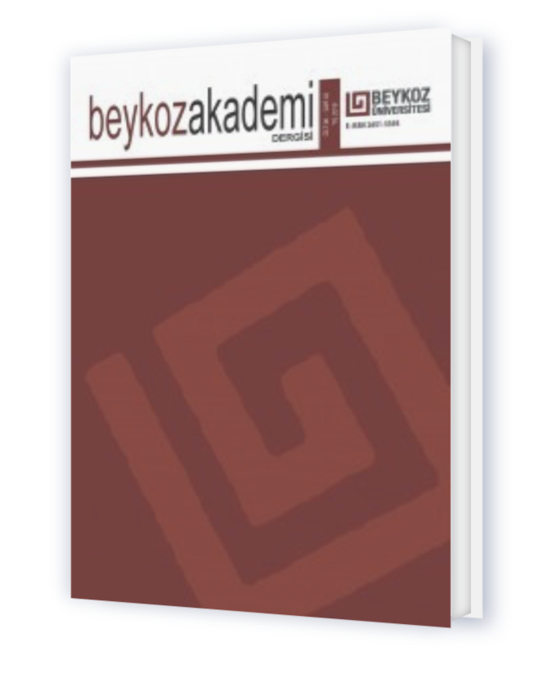

**Source:** Times New Roman, 10 point, left aligned, only the text "Source" in Bold.

Tables, graphs, and figures are numbered separately in each section and appendix. Table, graph, and figure names are written right next to the number. Tables, graphs, and figures should be placed with a line space below the number and name line. The title should be in Times New Roman, 12-font size, centered, and bold. A reference text is given after the lower border of tables, graphs, and figures, without any spaces. The source reference is “Source: ……” under the table, graph, or figure, and is written in Times New Roman, 10-font size, left-aligned, with only the text "Source" in bold.

**3. Method**

In this section, the research method should be explained. Sampling preference, hypotheses, research method, data collection technique, and analytical methods should be explained in detail.

In this section, the research method should be explained. Sampling preference, hypotheses, research method, data collection technique, and analytical methods should be explained in detail.

**4. Findings and/or Discussion**

In this section, the findings of the research should be explained in a discussion with the literature. In this section, the findings of the research should be explained in a discussion with the literature.

**5. Results and Recommendations**

In this section, the results and recommendations of the study should be presented.

**References**

References are under a separate heading, Times New Roman, font size 12, justified. Line Spacing; Single. Indentation; Special; Hanging; It should be set as 1.25 cm. The rules in the APA 7 reference system (http://www.apastyle.org/) should be used when citing in-text and arranging bibliography in articles submitted to the journal. Find the example representation below:

Aron, L., Botella, M. ve Lubart, T. (2019). Culinary arts: Talent and their development. In R. F. Subotnik, P. Olszewski-Kubilius, & F. C. Worrell (Eds.), *The psychology of high performance: Developing human potential into domain-specific talent (ss.* 345–359). American Psychological Association. https://doi.org/10.1037/0000120-016

Bologna, C. (2019, Ekim 31). *Why some people with anxiety love watching horror movies*. HuffPost. https://www.huffpost.com/entry/anxiety-love-watching-horror-movies_l_5d277587e4b02a5a5d57b59e

Evans, A. C., Jr., Garbarino, J., Bocanegra, E., Kinscherff, R. T. ve Márquez-Greene, N. (2019, August 8–11). *Gun violence: An event on the power of community*[Conference presentation]. APA 2019 Convention, Chicago, IL, United States. https://convention.apa.org/2019-video

Grady, J. S., Her, M., Moreno, G., Perez, C. ve Yelinek, J. (2019). Emotions in storybooks: A comparison of storybooks that represent ethnic and racial groups in the United States. *Psychology of Popular Media Culture*, 8(3), 207–217. https://doi.org/10.1037/ppm0000185

Hygum, E. ve Pedersen, P. M. (Eds.). (2010). *Early childhood education: Values and practices in Denmark.* Hans Reitzels Forlag. https://earlychildhoodeducation.digi.hansreitzel.dk/

Jackson, L. M. (2019). *The psychology of prejudice: From attitudes to social action*(2nd ed.). American Psychological Association. https://doi.org/10.1037/0000168-000

Kabir, J. M. (2016). Factors influencing customer satisfaction at a fast food hamburger chain: *The relationship between customer satisfaction and customer loyalty* (Publication No. 10169573) [Doctoral dissertation, Wilmington University]. ProQuest Dissertations & Theses Global.

National Cancer Institute. (2019). *Taking time: Support for people with cancer*(NIH Publication No. 18-2059). U.S. Department of Health and Human Services, National Institutes of Health. https://www.cancer.gov/publications/patient-education/takingtime.pdf

1. Personal information of the author (title, affiliation e-mail address) and ORCID information of the author should be stated in the footnote in Times New Roman, 9 font-size.